Annual Report of Programs/Projects undertaken by Amba Foundation for the year 2005-2006.

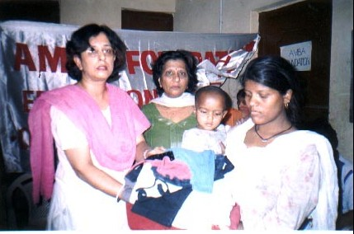
Amba comes to the aid of fire victims

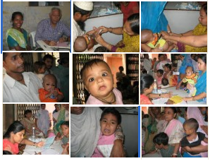
Health Center activities at a glance

Annual Report of Programs/Projects undertaken by Amba Foundation for the year 2005-2006.

I Health Programs

a. General Health

a.1 The Organization is running a health center/dispensary in Majboor Nagar JJ cluster for the benefit of the slum dwellers and adjoining areas. The Center offers free consultancy by qualified and dedicated doctors and free medicines to all the patients. The dispensary is open everyday from 9 a.m. to 1 p.m. Under this program 11,000 patients have been given treatment at the center in the last one year.

a.2 A common problem is of anemia among the patients. This is due to malnutrition on one hand and stomach worms on the other. A free De-worming Camp was conducted where free de-worming tablets and syrup was given to the people. Nearly 150 persons were covered under this Project.

a.3 A month long ‘Family health Awareness’ program was conducted at our health Centre. This was to educate the people on HIV AIDS, how it is transmitted, and the best way to safeguard against this disease was in taking precautions against its transmission. The message against HIV AIDS was spread via talks, posters, pamphlets and street plays preformed by the youth of the community. 900 people were covered under this program

a.4 A base line Survey of 500 women (15-49yrs) living in the slum areas along
National Highway-24, in east district of Delhi was conducted. The survey was conducted to understand the health profile and needs of the target women in this age group. The data was collected & analyzed for all the RCH indicators such as RTI infections, usage of family planning methods, age of marriage & conception and immunization of infants.

- Women’s Health Program

b.1 Under the Women’s health program the services of a gynecologist is available at the dispensary once a week. The poor women are provided antenatal & postnatal care along with family planning advice. The women are given free medicines along with free iron & calcium supplements. In the last year nearly a 1000 women were given treatment under this program.

b.2 Healthy Motherhood Camp was organized to provide young mother’s to be and mothers free health check ups, iron and calcium supplements.100 women benefited from this camp.

Child Health Program

c.1 Free Immunization Camps for infants were organized at our health centre under the Immunization program of the Government of India. A large number of new born & infants were given polio drops, DPT & Measles vaccinations.

c.2 All the children enrolled at our non formal education are given complete physical check up and free treatment and their parents advised for follow up wherever required.

c.3 In collaboration with ‘Rotary Club Inner Wheel’ A day long Workshop on the ‘Importance of breast feeding’ was conducted for young mothers. The doctors & counselors educated the mothers on the importance of breast feeding their child, its proper care and nutrition.100 women were covered under this program.

II Non Formal programs for under privileged children.

- Educational support to school and non school going children.

The focus group under this project is children in the age group 4-15 years living in the adjoining slums & colonies.

The children coming to our center are from poor backgrounds, their parents working as casual labour to skilled workers and petty vendors & hawkers. The majority of the mothers are illiterate while fathers are middle school to high school pass. Although the majority of these children are enrolled in govt schools, there is a high level of school drop outs. This is because of economic reasons and the lack of proper environment at school & home. This results in very poor level of education and literacy among these children. Over 160 such children were enrolled at our centers. They were taught basic reading , writing & maths , to help them improve their performance and curb drop outs from school.

- Nursery & Kindergarten

This program is being run for children in the age group 3-6 years living in the juggi cluster of majboor nagar. 35 children were covered under this project. The children are initiated into learning through the play way method. The aim is to integrate these children into the educational system
early on. It provides safe day care and an opportunity for the older sibling to attend school. Free healthcare is also provided to these children.

- Basic Computer literacy & education program

All the children at our non formal education center are given basic computer literacy lessons and hands on training. “Habitat learning Centre” of the ‘India Habitat Centre’ started its “Extension center” for our children in October 2004 and are partners in this program. Short training capsules were also conducted for children during the summer months.
200 children were covered under this project.

- English Speaking Workshop

A two week long workshop was conducted to teach the children English speaking and conversation skills. Volunteers designed and conducted this workshop comprising of 30 children.

- Workshop for Adolescent Girls

A legal literacy & awareness workshop was conducted for young girls. They were told about their rights, different laws affecting them and their legal rights .Also the method and precautions to be taken for registration of an FIR at the Police Station in case of any dispute.

- Workshop on ‘Access to education’

To integrate the school dropouts and working children back to the education system a day long workshop was conducted to educate them on the various options available for enrolling through the National Open Schools for completing their education & avenues for vocational training through Government Institutes and it is.

- Financial assistance/scholarships to deserving & needy children.

Financial assistance is given to needy & deserving children studying in school. Assistance is given for fees, books, uniform and other related educational expenses. 26 children benefited under this scheme.Further, children desirous of doing undergraduate degree/diploma are given fees reimbursement for a course of their choice.

- Dance & Theatre Workshops for children.

This workshop is conducted to encourage overall personality development of the children. It is part of the overall program to educate and create awareness among them on various social issues. Trained volunteers undertake these groups and have groomed a group of talented and creative children. The children have preformed plays & dances at various forums in the city. 40 children have benefited from these workshops. This year too, the children preformed at the Annual HLC Festival at the India Habitat Centre
A month long summer theatre workshop was also sponsored by Sahitya kala Parishad, Delhi Govt. for the children at our centre, at the end of which the children put up a play and preformed at the ‘Bal Sangam’ a Festival of Plays at Delhi.

- Art & Craft workshop.

Being a part of the overall personality development programs the children are encouraged to express themselves freely and imaginatively
through the medium of drawing , painting and handicrafts. Two such workshops were conducted covering 80 children. Greeting cards and paintings are also made by the children from time to time.

- Football coaching for young Boys.

In collaboration with NGOs working in the area of child development & education, ‘Kutumb’ organized a month long Football Coaching Camp for children. The Camp was conducted by national level players at a public school in Delhi.12 children from our Centers participated in this Camp which served as a huge source of inspiration & learning for them.

- Workshop on Road Safety

10 boys & girls from Amba attended a Road Safety Workshop conducted in collaboration with IHC . The children were told about safe road practices and encouraged to imbibe them for their own and the public’s safety.

III Community Development Programs.

- Emergency Help for fire victims :

A devastating fire destroyed a number of homes & hutments at the majboor nagar jj camp, Mandawali. To provide immediate help & relief to the victims, it provided shelter at its Centre for women & children. In addition it mobilized & organized help in the form of rations, clothes, utensils and other items of need for the families affected by the fire. 30 such families were rendered assistance during this time. All those suffering from injuries & minor burns were given First-Aid treatment by our
doctors.

- Workshop on the ‘Right of information Act’

Workshops were conducted for the basti women and youth. The participants were told about how they can use the RTI Act to know more about their rights and get better rations through the public distribution system.10 women participated in these workshops.

- Women’s awareness program on health & hygiene.

To create awareness on issues of health, hygiene and parenting, interactive groups of women were formed and counselors held monthly meetings with the group. The women were encouraged to discuss their problems and solutions were discussed amongst them so as to bring about an improvement in their lives. 100 women were covered under this project.

- Vocational training for women in handicrafts, stitching & knitting.

The poor women are taught various crafts such as divyas, candles, paper bags, etc. The volunteers also teach the women knitting new patterns and designs for sweaters etc. The Organization helps in marketing the products made by the women through stalls put up during festival time in various parts of the city. This helps the women to earn some livelihood for themselves.

- Creating Linkages for income generation for women living in slums.

To create avenues for income generation among poor women, the Organization interfaced and created linkages between exporters of hand embroidered products and the women of majboor nagar JJ cluster.
The women were supplied piece meal work to stitch beads etc and were paid according to the work done. A group leader among the women was chosen to take the responsibility of dispersal of work among the group and submitting the finished work back to the fabricator/exporter.

IV Capacity Building

The members, volunteers and employees of the Organization are encouraged to attend training programs and workshops for self growth.
The members & project coordinators attended a series of workshops conducted by the India Habitat Centre on Project budgets, execution & evaluation. Effective methods for monitoring & motivating people to work productively.
The teachers attended various workshops for teaching skills and computer literacy while the doctors & counselors attended programs on HIV AIDS, adolescent health and safe motherhood.

V Financial status :

- Source of Funds.

The major source of funds for the financial year was through donations raised from individuals in India and abroad, subscription from members and also by Community contributions.
Other institutional donors were ‘Noon.ch from Switzerland, ‘Asha for Education’ USA and ‘The Hindu Society of Ottawa’ Canada.

VI Future Programs & Plans

The Organization plans to maintain the main thrust of its welfare programs in education and health of the underprivileged. In addition it plans to create linkages with established vocational institutes for enrolling young girls & women to initiate them for vocational training programs. This is to ensure the empowerment of improvised women in urban slums.

…………………………………….

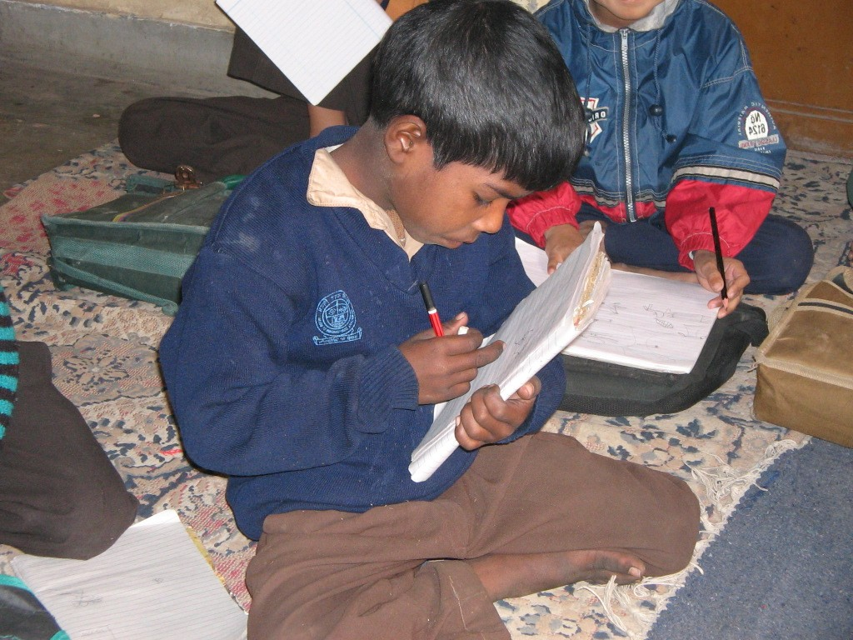
A student of our education center

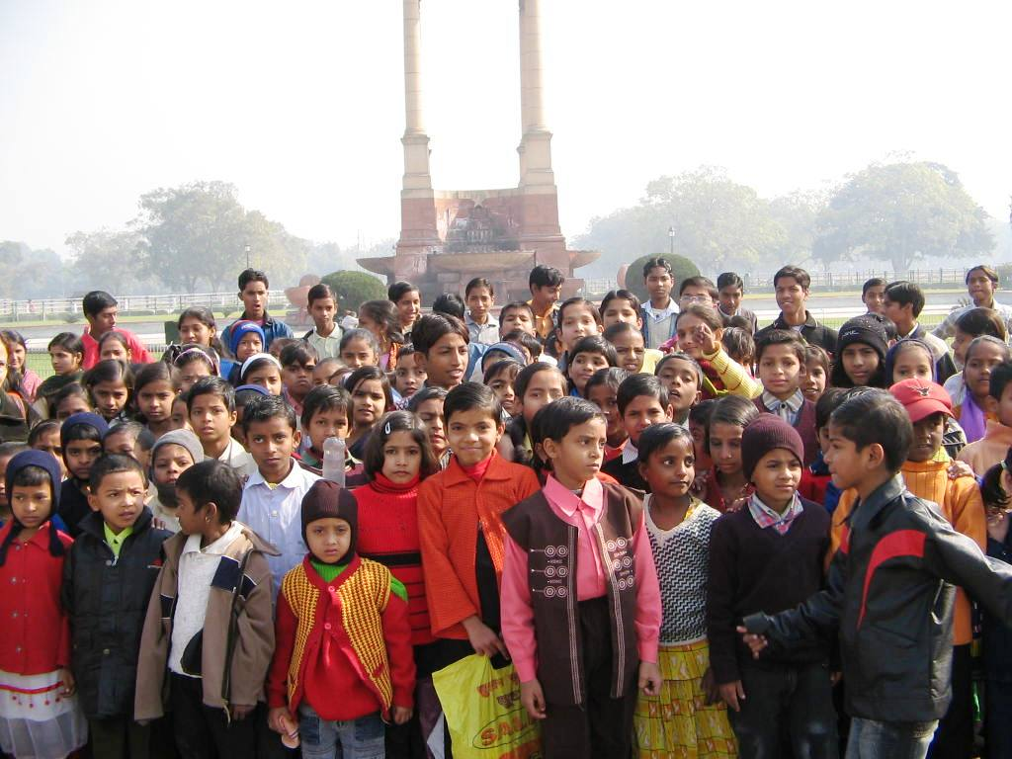
Picnic at India Gate

